Automatic Retractable Roof
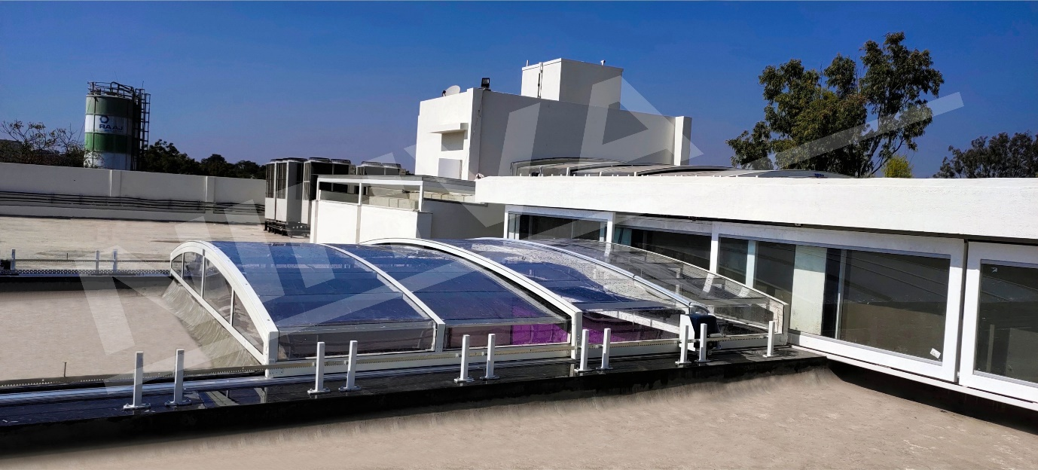

Retractable roof is a new innovation done by NIHVA for Bungalows, Hotels, Hospitals, Villas, Apartments, Commercial complex, Offices, where we can add these skylights which allows partial sunlight to enter in premises during day time and sky view at night. Roofs can be operated in many ways like folding roof, sliding roof, telescopic roof, single sided, double sided, vertical lift, inclined lift and etc.
Unique features of Automatic sliding roof -
- Non-Corrosive materials like Aluminum Alloy Profiles, Stainless Steel Fasteners, Rubber sealing, and Polycarbonate Sheet Fillings are used in the construction of these systems.
- Complete enclosure with doors, locking systems, rubber seals. Lightweight solution for terraces, roofing systems, pools, balconies, patios, smoking zones, and a lot more applications.
- Completely waterproof and can be air conditioned if the area is enclosed.
- No need for any license from municipal authorities for terrace roofing, since it’s completely retractable.
- Easily relocatable with our highly trained technical assistance team in a short time.

Automatic Vertical Sliding Window
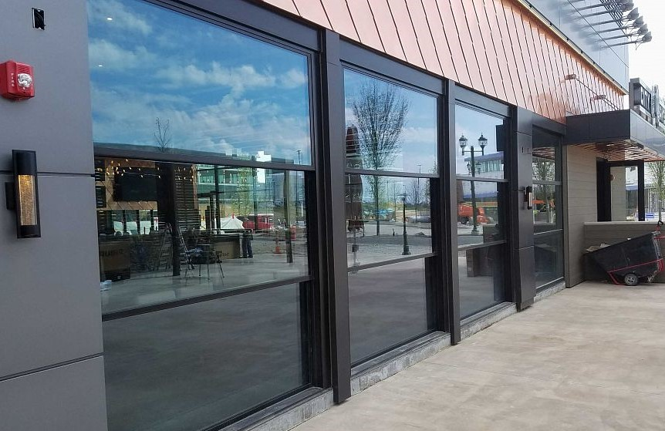
Panoramic windows represent a new paradigm in automatic vertical sliding window. The motion can be downwards or upwards.
In any of these situations, Vertical sliding windows provides a better view through natural daylighting, a better utilization of floor and ceiling space, and even a better air ventilation scheme.
Our aluminum and glass retractable structures are innovative, functional, and aesthetically attractive. They are used in restaurants, cafes and hotels, sports venues, commercial and residential pools, patios, and industrial facilities.
These operable glass walls, windows and doors offer an elegant vertical retraction design that provides unobstructed views up to 18 feet wide and frees up valuable floor space.
Balcony Enclosure
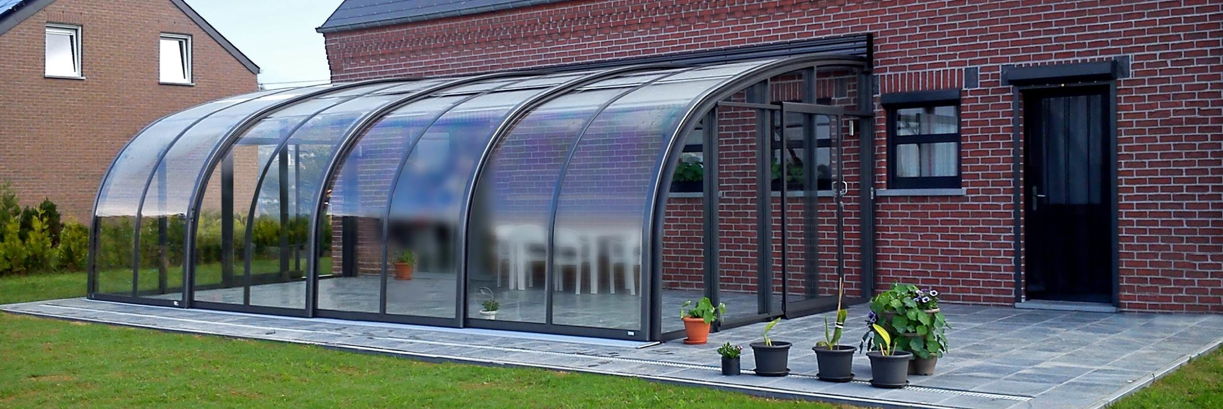
Balcony Enclosure is important to design rooftop spaces into the plans from the beginning. NIHVA’s balcony enclosure allows you to transform your open space into a well- protected refuge that invites you to spend more and more of your precious leisure time.
NIHVA enhances the idea of open air sitting with better view making it possible for you with concept of Balcony Enclosure. The factor of excitement in our retractable balcony enclosure structures is extravagant.
We at NIHVA challenge ourselves to plant the concept of outdoor freedom and indoor comfort in our client’s business. Our thought of modern architectural design derives the innovative product of balcony enclosure

Swimming Pool Enclosure
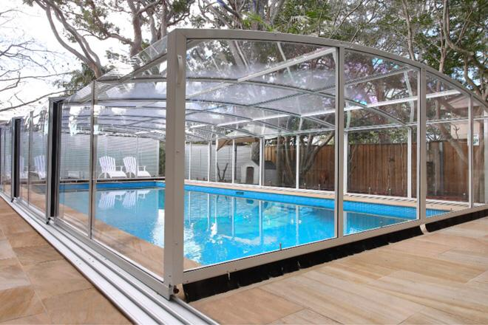
Retractable Pool Enclosures are made from aluminium frames, impact resistance & absolutely shatterproof polycarbonate transparent panels that encloses swimming pools. It creates an environment protecting Pool from the outside elements thus, transforming the pool area to an indoor pool.
You can lock your swimming pool when needed, limit your child's access to the pool and prevent children or animals from falling into the pool, protecting the safety of your children and pets.
With NIHVA pool enclosures, you can easily avoid getting dirt, dust, leaves, or insects in your pool. This allows for a neat and clean pool all the time. Pool enclosures offer much more than top notch functionality, it offers eloquence and radiance as well.

Dome Enclosure
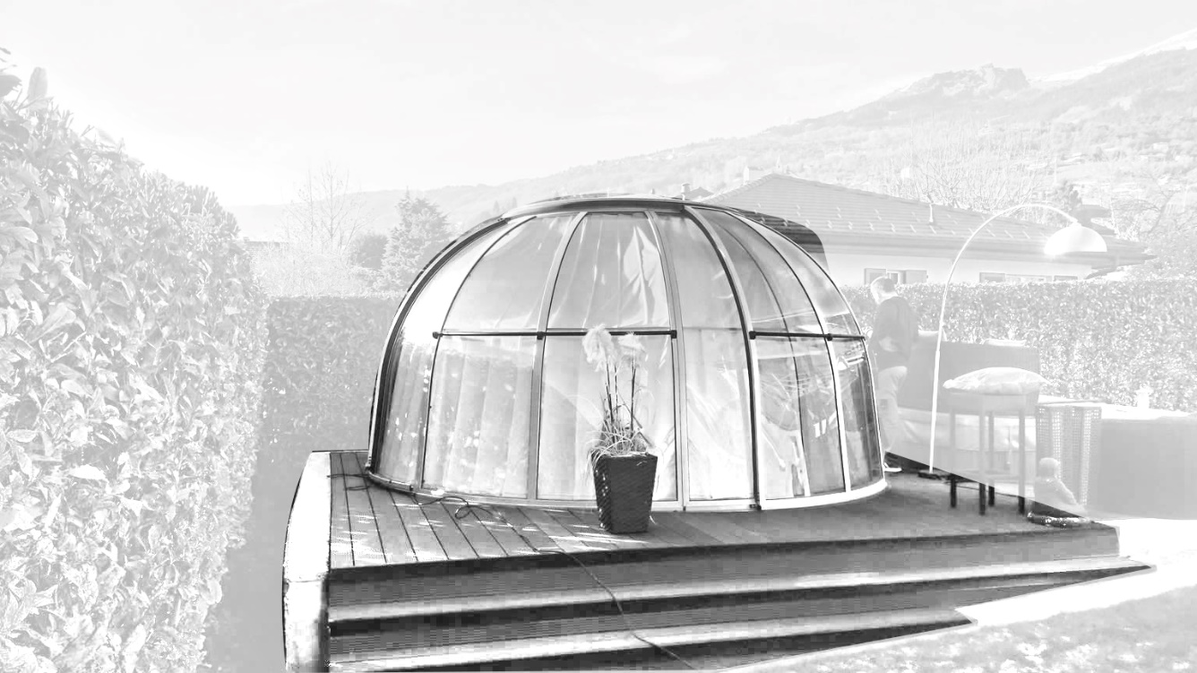
Dome design takes open-air- living to a whole new level with help of requires engineering & vision expertise. Every concept needs to be durable, functional and easy to operate. NIHVA with its decade of experience in installation of retractable systems has made the combination of day-lighting and open-air- living at its very best.
Retractable dome systems have the rail system thus, the system can be done on existing building structure or if required with a support of steel structure.
Dome retractable systems also provides a low height system better suited for climates with low to no snow accumulation.

--------------------------------------------------------------------------------------------------------------------------
NIHVA Automatic retractable systems are environmentally, friendly and efficient. Good thermal insulation is provided by Insulated glazing. The options of full or partial opening give you the control of your climate the elements of nature.

